The **count-and-say** sequence is a sequence of digit strings defined by the recursive formula:

* countAndSay(1) = "1"
* countAndSay(n) is the way you would "say" the digit string from countAndSay(n-1), which is then converted into a different digit string.

To determine how you "say" a digit string, split it into the **minimal** number of substrings such that each substring contains exactly **one** unique digit. Then for each substring, say the number of digits, then say the digit. Finally, concatenate every said digit.

For example, the saying and conversion for digit string "3322251":

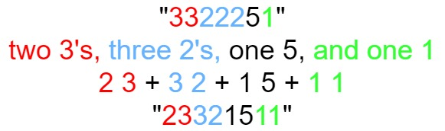

Given a positive integer n, return *the* nth *term of the* ***count-and-say*** *sequence*.

**Example 1:**

Input: n = 1  
Output: "1"  
Explanation: This is the base case.

**Example 2:**

Input: n = 4  
Output: "1211"  
Explanation:  
countAndSay(1) = "1"  
countAndSay(2) = say "1" = one 1 = "11"  
countAndSay(3) = say "11" = two 1's = "21"  
countAndSay(4) = say "21" = one 2 + one 1 = "12" + "11" = "1211"

**Constraints:**

* 1 <= n <= 30